Core Java 8 and Development Tools

Lab Book

Document Revision History

|  |  |  |  |
| --- | --- | --- | --- |
| Date | Revision No. | Author | **Summary of Changes** |
| 17-11-2013 | 1.0 | Rathnajothi P | As of updated module content, designed lab book |
| 28-05-2015 | 2.0 | Vinod Satpute | Updated to include new features of Java SE 8, Junit 4 and JAXB 2.0 |
| 25-05-2016 | 3.0 | Tanmaya K Acharya | Updated as per the integrated ELT TOC |
| 10-01-2017 | 4.0 | Vaishali Srivastava | TOC Updated as per BU Requirements for VNV Automation |

Table of Contents

Document Revision History 2

Table of Contents 3

Getting Started 4

Overview 4

Setup Checklist for Core Java 4

Instructions 4

Learning More (Bibliography if applicable) 4

Problem Statement/ Case Study (If applicable) 5

Lab 1: Working with Java and Eclipse IDE 6

1.2: Create Java Project 8

1.3: Using offline Javadoc API in Eclipse 11

Lab 2: Inheritance and Polymorphism 16

Lab 3: Arrays, Regular Expression, Exception Handling 18

Lab 4 : Files IO and Collections 19

Lab 5: Introduction to Junit 20

5.1: Configuration of JUnit in Eclipse 20

5.2: Writing JUnit tests 24

Appendix A: Table of Figures 27

Getting Started

## Overview

This lab book is a guided tour for learning Core Java version 8 and development tools. It comprises of assignments to be done. Refer the demos and work out the assignments given by referring the case studies which will expose you to work with Java applications.

## Setup Checklist for Core Java

Here is what is expected on your machine in order to work with lab assignment.

Minimum System Requirements

* Intel Pentium 90 or higher (P166 recommended)
* Microsoft Windows 7 or higher.
* Memory: (1GB or more recommended)
* Internet Explorer 9.0 or higher or Google Chrome 43 or higher
* Connectivity to Oracle database

Please ensure that the following is done:

* A text editor like Notepad or Eclipse is installed.
* JDK 1.8 or above is installed. (This path is henceforth referred as <java_home>)

## Instructions

* + - For all Naming conventions, refer Appendix A. All lab assignments should adhere to naming conventions.
    - Create a directory by your name in drive <drive>. In this directory, create a subdirectory java_assignments. For each lab exercise create a directory as lab <lab number>.

## Learning More (Bibliography if applicable)

* <https://docs.oracle.com/javase/8/docs/>
* Java, The Complete Reference; by Herbert Schildt
* Thinking in Java; by Bruce Eckel
* Beginning Java 8 Fundamentals by KishoriSharan

Problem Statement/ Case Study (If applicable)

1. **Bank Account Management System:**

* Funds Bank needs an application to feed new Account Holder information. AccountHolder will be a person. There are two types of accounts such as SavingsAccount, CurrentAccount.

1. **Employee Medical Insurance Scheme:**

* By default, all employees in an organization will be assigned with a medical insurance scheme based on the salary range and designation of the employee. Refer the below given table to find the eligible insurance scheme specific to an employee.

|  |  |  |
| --- | --- | --- |
| **Salary** | **Designation** | **Insurance scheme** |
| >5000 and < 20000 | System Associate | Scheme C |
| >=20000 and <40000 | Programmer | Scheme B |
| >=40000 | Manager | Scheme A |
| <5000 | Clerk | No Scheme |

Lab 1: Working with Java and Eclipse IDE

|  |  |
| --- | --- |
| **Goals** | Learn and understand the process of:   * + Setting environment variables   + Creating a simple Java Project using Eclipse 3.0 or above |
| **Time** | 195 minutes |

1.1: Setting environment variables from CommandLineSolution:

**Step 1:** Set **JAVA_HOME** to Jdk1.8 using the following command:

* **Set JAVA_HOME=**C:\Program Files\Java\jdk1.8.0_25

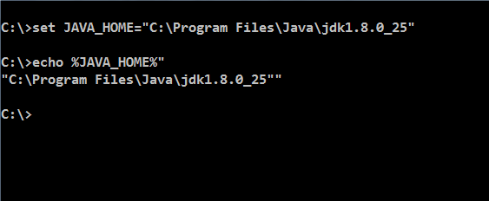

Figure 1: Java program

**Step 2:** Set PATH environment variable:

* **Set PATH=%PATH%;%JAVA_HOME%\bin;**

**Step 3:** Set your current working directory and set classpath.

* Set CLASSPATH=.

**Note:** Classpath searches for the classes required to execute the command. Hence it must be set to the directory containing the class files or the names of the jars delimited by ;

**For example:** C:\Test\myproject\Class;ant.jar

 Alternatively follow the following steps for setting the environment variables

**Alternate approach:**

**Step 1:** Right click **My Computers**, and select **Properties**🡪**Environment Variables**.

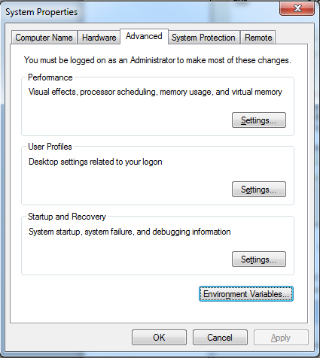

Figure 2: System Properties

**Step 2:** Click **Environment Variables**. The Environment Variables window will bedisplayed.

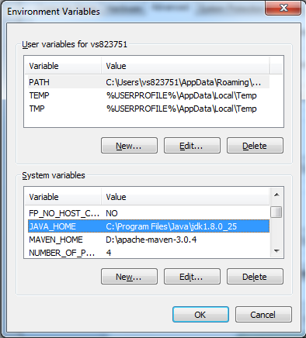

Figure 3: Environment Variables

**Step 3:** Click **JAVA_HOME** System Variable if it already exists, or create a new one and set the path of JDK1.8 as shown in the figure.

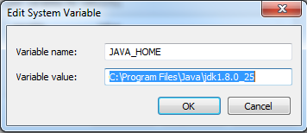

Figure 4: Edit System Variable

**Step 4:** Click **PATH** System Variable and set it as ***%PATH%;%JAVA_HOME%\bin***.

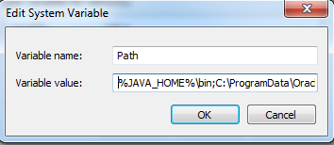

Figure 5: Edit System Variable

**Step 5:** Set **CLASSPATH** to your working directory in the **User Variables** tab.

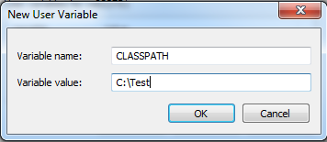

Figure 6: Edit User Variable

## 1.2: Create Java Project

Create a simple java project named ‘MyProject’.

Solution:

**Step 1:** Open **eclipse 4.4**(or above)

**Step 2:** Select **File**🡪**New**🡪**Project** 🡪**Java project**.

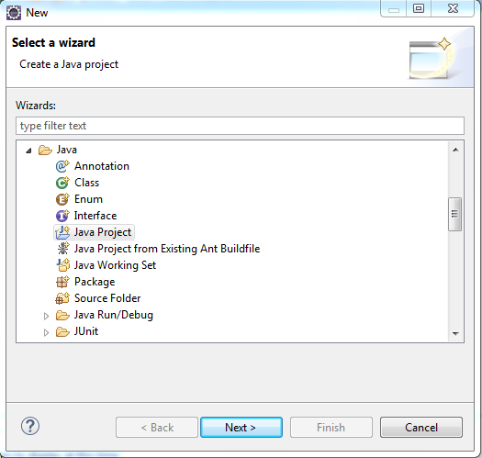

Figure 7: Select Wizard

**Step 3:**Click **Next** and provide name for the project.

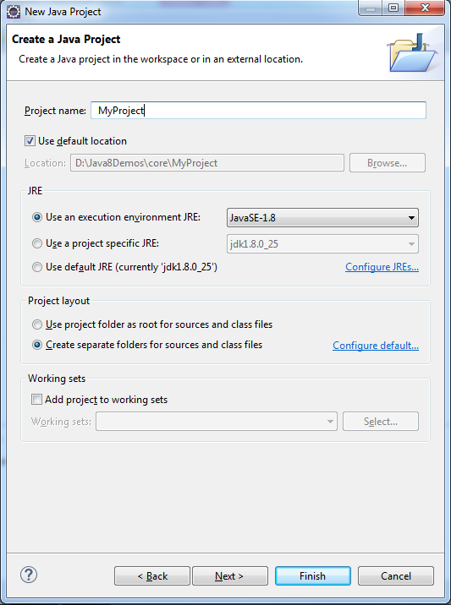

Figure 8: New Java Project

**Step 4:** Click **Next** and select build options for the project.

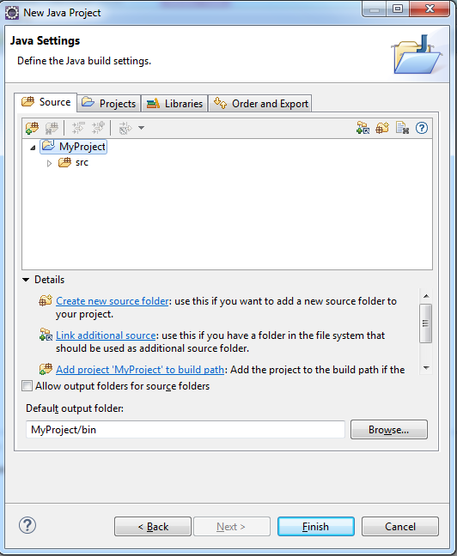

Figure 9: Java Settings

**Step 5:** Click **Finish** to complete the project creation.

**Step 6:** Right-click **myproject**, and select resource type that has to be created.

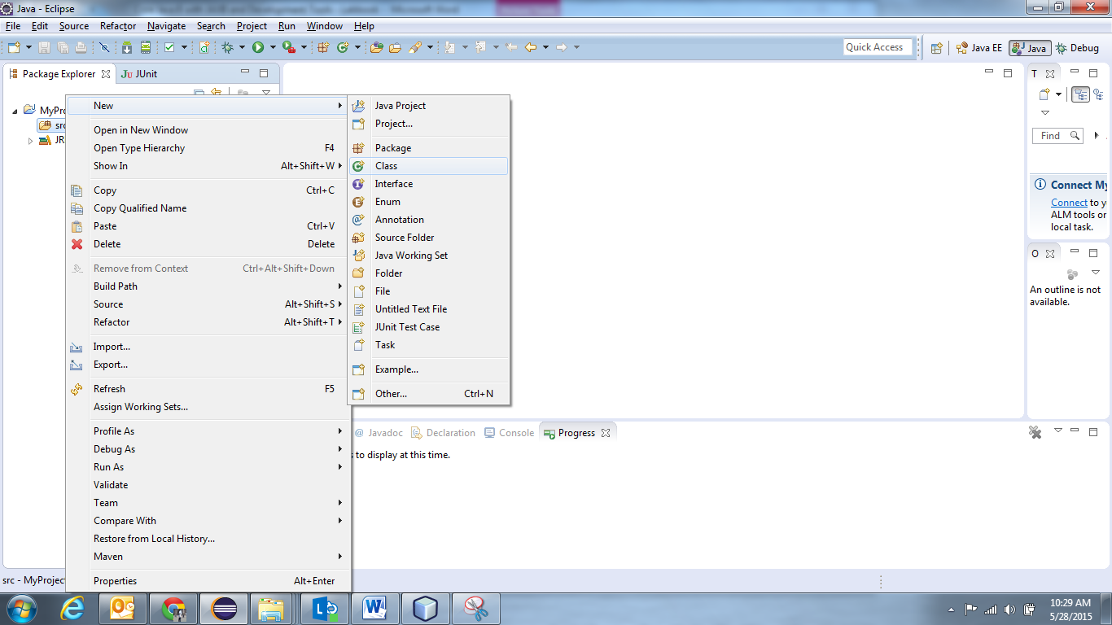

Figure 10: Select Resource

**Step 7:** Provide name and other details for the class, and click **Finish**.

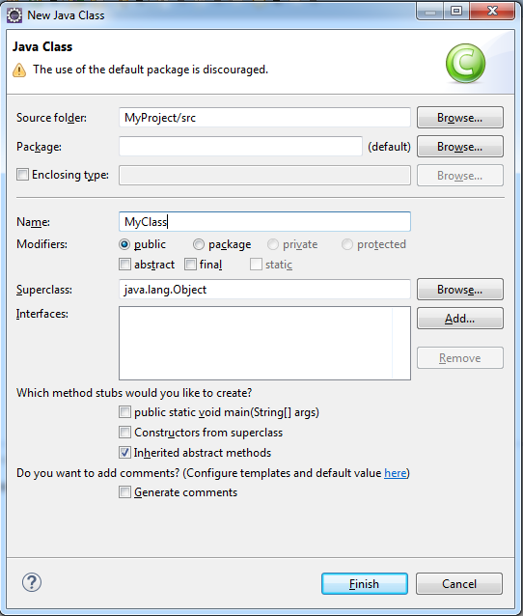

Figure 11: Java Class

This will open **MyClass.java** in the editor, with ready skeleton for the class, default constructor, **main ()** method, and necessary **javadoc** comments.

To run this class, select **Run** from toolbar, or select **Run As** 🡪**Java application**. Alternatively, you can select **Run.** and you will be guided through a wizard, for the selection of class containing **main()** method.

Console window will show the output.

## 1.3: Using offline Javadoc API in Eclipse

**Step 1:** Open **eclipse 4.4**(or above)

**Step2:** From eclipse Window 🡪 Preferences 🡪Java 🡪 "Installed JREs" select available JRE (jdk1.8.0_25 for instance) and click Edit.

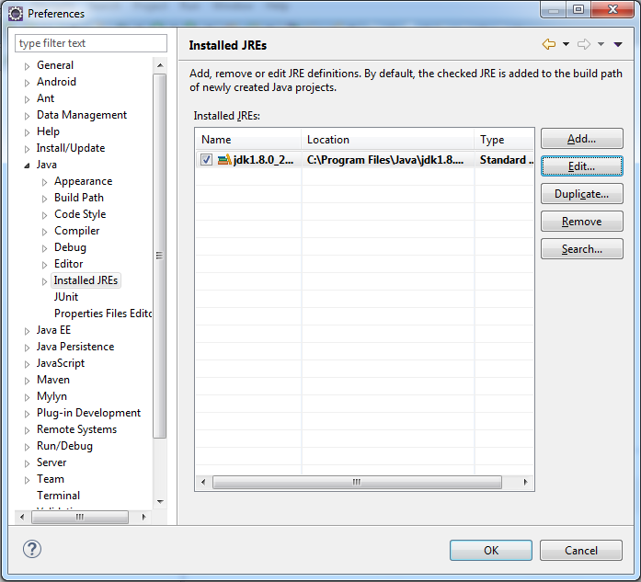

**Step3:**Select all the "JRE System libraries" using Control+A.

**Step 4:** Click "Javadoc Location"

**Step 5:**Change "Javadoc location path:" from <http://download.oracle.com/javase/8/docs/api/> to "file:/E:/Java/docs/api/".

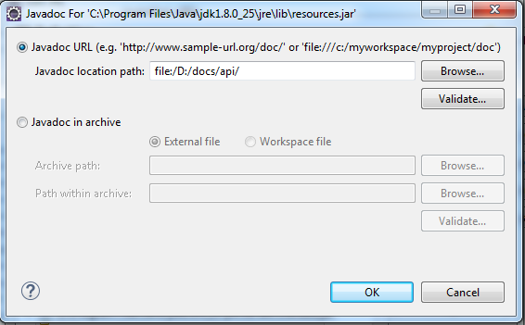

**Step 6**: Close all windows by either clicking on ok/apply.

**Step 7**: Open the Javadoc view from Window 🡪 Show View 🡪 Javadoc.

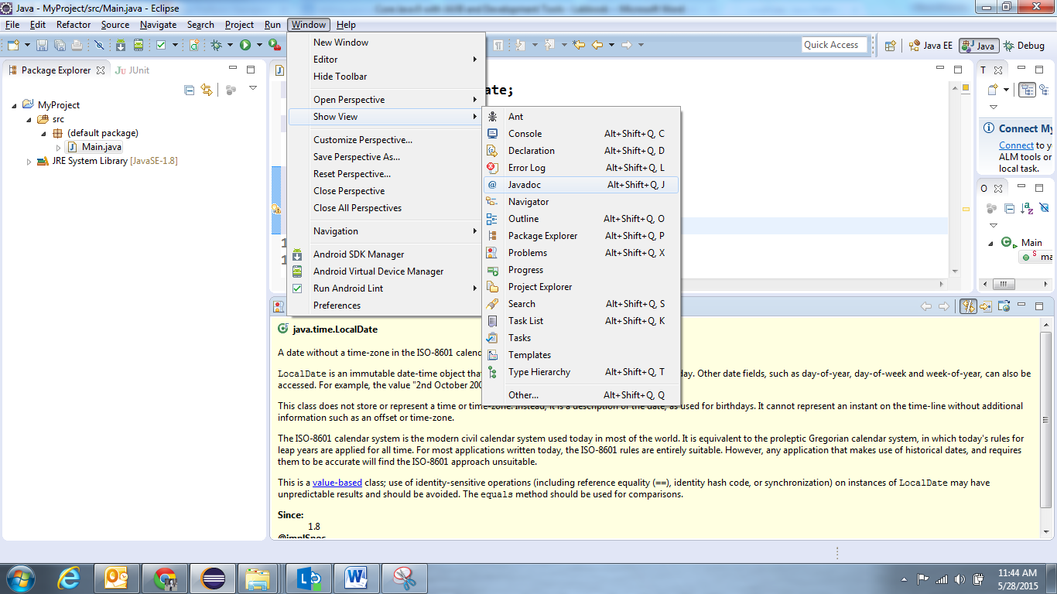

**Note:** Henceforth whenever you select any class or method in Editor Window, it Javadoc view will display the reference documentation.

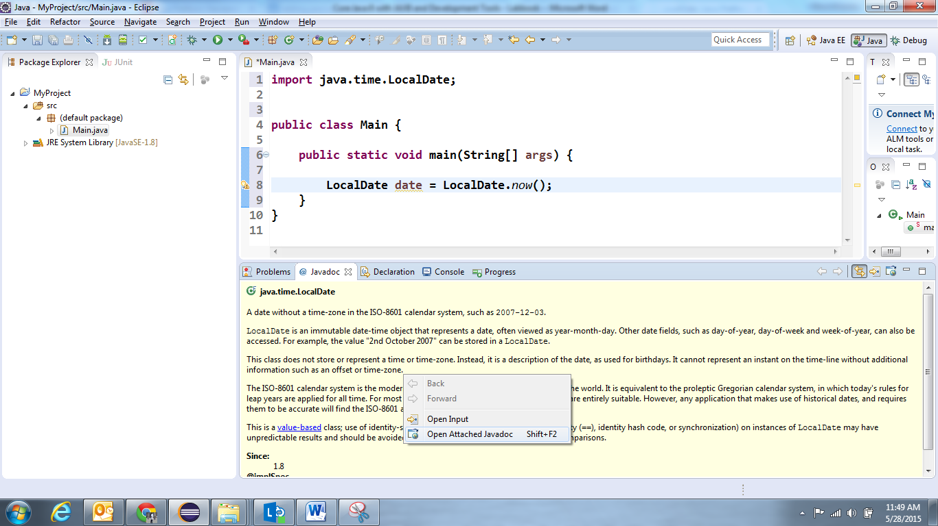

If you want to open the Java documentation for specified resource as html page, right click in the Javadoc view 🡪 Open Attached Javadoc.

**1.4:** Write a java program to print person details in the format as shown below:

Person Details:

____________

First Name: Divya

Last Name: Bharathi

Gender: F

Age: 20

Weight: 85.55

Figure 12: Sample output of Person details

**1.5:** Write a program to accept a number from user as a command line argument and check whether the given number is positive or negative number.

**1.6**: Refer the class diagram given below and create person class.

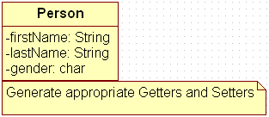

Figure 13: Class Diagram of Person

Create default and parameterized constructor for Person class.

Also Create “PersonMain.java” program and write code for following operations:

1. Create an object of Person class and specify person details through constructor.
2. Display the details in the format given in Lab assignment 1.4

**1.7:** Modify Lab assignment 1.6 to accept phone number of a person. Create a new method to implement the same and also define method for displaying person details.

**1.8:** Modify the above program, to accept only ‘M’ or ‘F’ as gender field values. Use Enumeration for implementing the same.

**1.9:** Create a method which can perform a particular String operation based on the user’s choice. The method should accept the String object and the user’s choice and return the output of the operation.

Options are

* Add the String to itself
* Replace odd positions with #
* Remove duplicate characters in the String
* Change odd characters to upper case

**1.10:** Create a method that accepts a String and checks if it is a positive string. A string is considered a positive string, if on moving from left to right each character in the String comes after the previous characters in the Alphabetical order. For Example: ANT is a positive String (Since T comes after N and N comes after A). The method should return true if the entered string is positive.

**1.11:** Create a program to accept date and print the duration in days, months and years with regards to current system date.

**1.12:** Revise exercise **1.11** to accept two LocalDates and print the duration between dates in days, months and years.

**1.13:** Create a method to accept product purchase date and warrantee period (in terms of months and years). Print the date on which warrantee of product expires.

**1.14:** Create a method which accept zone id and print the current date and time with respect to given zone. (Hint: Few zones to test your code. America/New York, Europe/London, Asia/Tokyo, US/Pacific, Africa/Cairo, Australia/Sydney etc.)

**1.15**: Modify Lab assignment 1.6 to perform following functionalities:

1. Add a method called calculateAge which should accept person’s date of birth and calculate age of a person.
2. Add a method called getFullName(String firstName, String lastName) which should return full name of a person

Display person details with age and full name.

Lab 2: Inheritance and Polymorphism

|  |  |
| --- | --- |
| **Goals** | At the end of this lab session, you will be able to:   * + Write a Java program that manipulates person details   + Working with Inheritance, Polymorphism |
| **Time** | 315 minutes |

**2.1:** Refer the case study 1 in Page No: 5 and create Account Class as shown below in class diagram. Ensure minimum balance of INR 500 in a bank account is available.

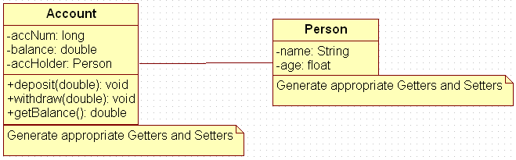

Figure 14: Association of person with account class

1. Create Account for smith with initial balance as INR 2000 and for Kathy with initial balance as 3000.(accNum should be auto generated).
2. Deposit 2000 INR to smith account.
3. Withdraw 2000 INR from Kathy account.
4. Display updated balances in both the account.
5. Generate toString() method.

**2.2:** Extend the functionality through Inheritance and polymorphism (Maintenance)

Inherit two classes Savings Account and Current Account from account class. Implement the following in the respective classes.

1. Savings Account
2. Add a variable called minimum Balance and assign final modifier.
3. Override method called withdraw (This method should check for minimum balance and allow withdraw to happen)
4. Current Account
5. Add a variable called overdraft Limit
6. Overridemethod called withdraw (checks whether overdraft limit is reached and returns a boolean value accordingly)

**2.3:** Refer the case study 2 in page no: 5 and create an application for that requirement by creating packages and classes as given below:

1. **com.cg.eis.bean**

In this package, create “Employee” class with different attributes such as id, name, salary, designation, insuranceScheme.

1. **com.cg.eis.service**

This package will contain code for services offered in Employee Insurance System. The service class will have one EmployeeService Interface and its corresponding implementation class.

1. **com.cg.eis.pl**

This package will contain code for getting input from user, produce expected output to the user and invoke services offered by the system.

The services offered by this application currently are:

1. Get employee details from user.
2. Find the insurance scheme for an employee based on salary and designation.
3. Display all the details of an employee.

**2.4:** Use overrides annotation for the overridden methods available in a derived class of an interface of all the assignments.

**2.5:** Refer the problem **statement 2.1**. Modify account class as abstract class and declare withdraw method.

Lab 3: Arrays, Regular Expression, Exception Handling

|  |  |
| --- | --- |
| **Goals** | At the end of this lab session, you will be able to:   * Create and use application specific exceptions |
| **Time** | 195 minutes |

**3.1:** Modify the Lab assignment **1.6** to validate the full name of an employee. Create and throw a user defined exception if first Name and lastName is blank.

**3.2:** Validate the age of a person in Lab assignment 2.1 and display proper message by using user defined exception. Age of a person should be above 15.

**3.3:** Modify the Lab assignment **2.3** to handle exceptions. Create an Exception class named as “EmployeeException”(User defined Exception) in a package named as “com.cg.eis.exception” and throw an exception if salary of an employee is below than 3000. Use Exception Handling mechanism to handle exception properly.

**3.4:** Write a program to store product names in a string array and sort strings available in an array.

Lab 4 : Files IO and Collections

|  |  |
| --- | --- |
| **Goals** | At the end of this lab session, you will be able to:   * + Read and write data using streams.   + Serialize and Deserialize objects |
| **Time** | 285 minutes |

**4.1:** Write a program to read content from file, reverse the content and write the reversed content to the file. (Use Reader and Writer APIs).

**4.2:** Create a file named as “numbers.txt” which should contain numbers from 0 to 10 delimited by comma. Write a program to read data from numbers.txt using Scanner class API and display only even numbers in the console.

**4.3:** Enhance the lab assignment **3.3** by adding functionality in service class to write employee objects into a File. Also read employee details from file and display the same in console. Analyze the output of the program.

**4.4:** Modify the above program to store product names in an ArrayList, sort strings available in an array List and display the names using for-each loop.

**4.5:** Modify the lab assignment **2.3** to accept multiple employee details and store all employee objects in a HashMap. The functionalities need to be implemented are:

1. Add employee details to HashMap.
2. Accept insurance scheme from user and display employee details based on Insurance scheme
3. Delete an employee details from map.

**Sample code Snippet of EmployeeServiceImpl class:**

|  |
| --- |
| public class EmployeeServiceImpl {  HashMap<String,Employee> list = new HashMap<String,Employee>();    public void addEmployee(Employee emp) {  //code to add employee  }  public boolean deleteEmployee(int id) {  // code to delete a employee whose id is passed as parameter  }  ………………..  } |

Lab 5: Introduction to Junit

|  |  |
| --- | --- |
| **Goals** | At the end of this lab session, you will be able to:   * + Configuring JUnit in Eclipse   + Using JUnit to write TestCase for standalone Java Applications |
| **Time** | 330 minutes |

## 5.1: Configuration of JUnit in Eclipse

Step 1:Create a Java project.

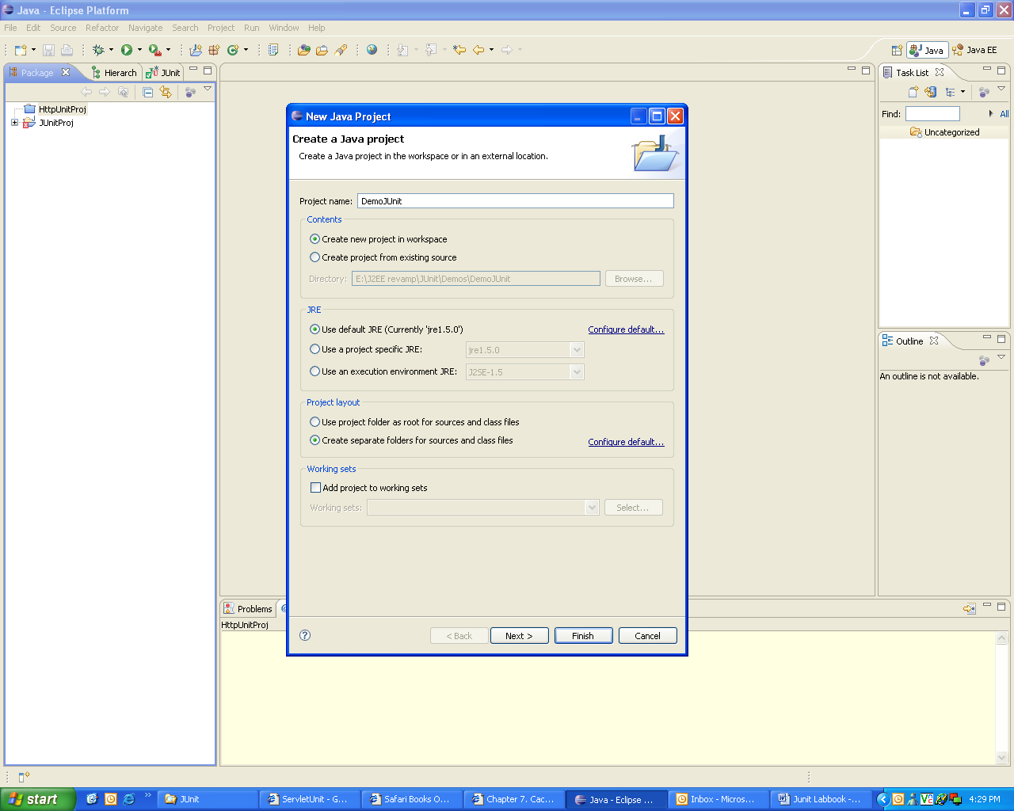

Figure 15: Creating Java Project in Eclipse

**Step 2:** Add **junit4.4.jar** in the build path of the project.

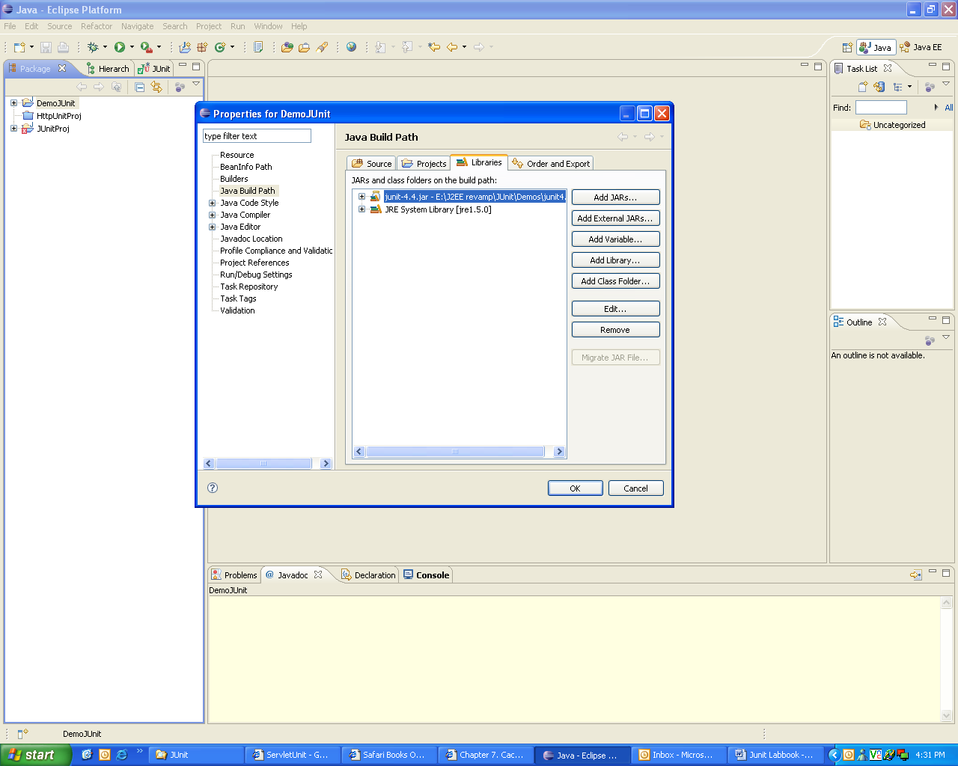

Figure 16: Adding junit4.4.jar in the build path

**Step 3:** Write the java class as follows:

|  |
| --- |
| public class Person  {  private String firstName;  private String lastName;  public Person(String fname,Stringlname)  {  if(fname == null &&lname==null){  throw new IllegalArgumentException("Both Names Cannot be NULL");  }  this.firstName=fname;  this.lastName = lname;  }  public String getFullName()  {  String first=(this.firstName != null)? this.firstName:"?";  String last=(this.lastName != null)? this.lastName:"?";  return first + " " + last;  }  public String getFirstName(){  return this.firstName;  }  public String getLastName(){  return this.lastName;  }  public static void main(String args[])  {  Person p=new Person("a","b");  System.out.println(p.getFirstName());  }  } |

Example 1: Person.java

**Step 4:** Write the JUnit test class.

* Create a JUnit test case in Eclipse.

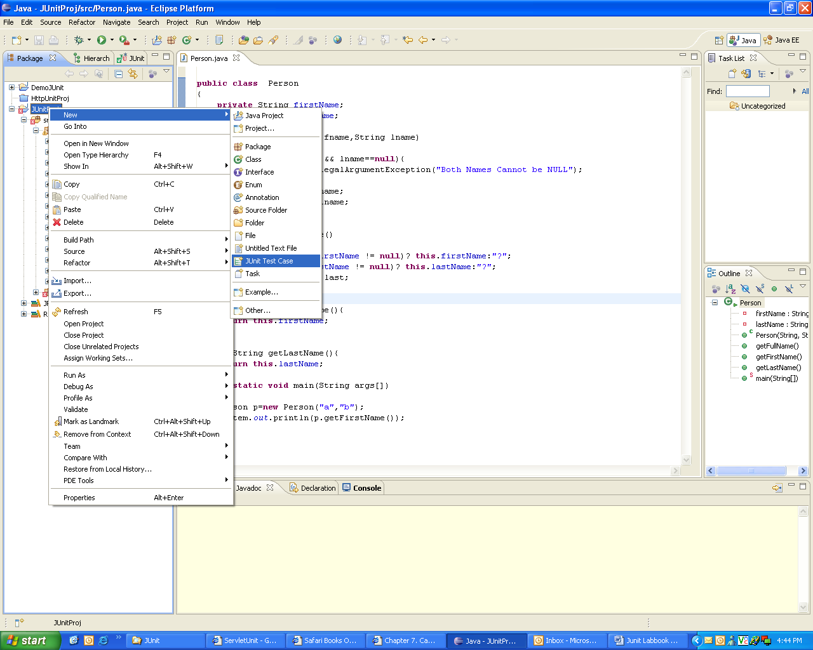

Figure 17: Adding the JUnit test case to the project

* A dialog box opens, where you need to specify the following details:
  + The Junit version that is used
  + The package name and the class name
  + The class under test
  + You can also specify the method stubs that you would like to create

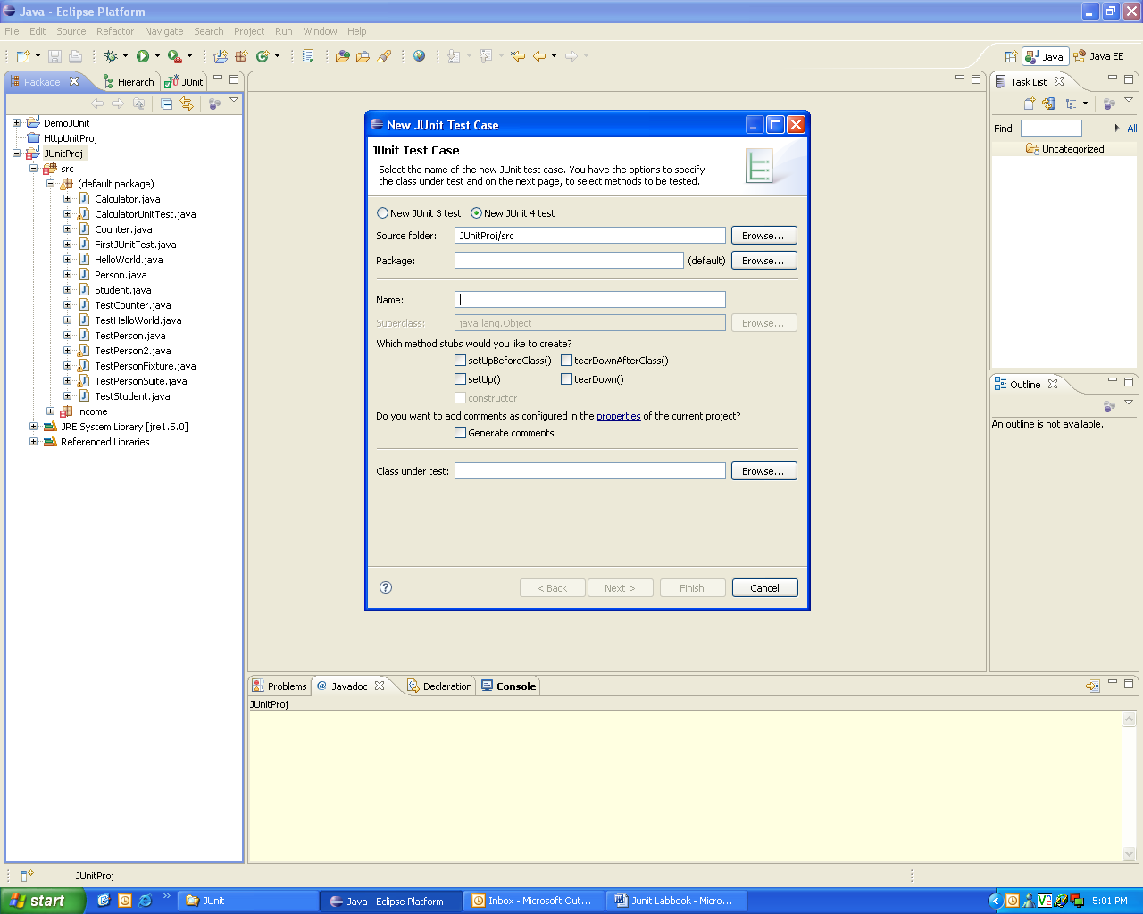

Figure 18: Specifying information for the test case

* Write the code as follows:

|  |
| --- |
| importorg.junit.*;  import org.junit.Test;  import static org.junit.Assert.*;  public class TestPerson2  {  @Test  public void testGetFullName()  {  System.out.println("from TestPerson2");  Person per = new Person("Robert","King");  assertEquals("Robert King",per.getFullName());  }    @Test (expected=IllegalArgumentException.class)  public void testNullsInName()  {  System.out.println("from TestPerson2 testing exceptions");  Person per1 = new Person(null,null);  }  } |

Example 2: TestPerson2.java

**Step 5:**Run the test case.

* Right click the test case class, and select **RunAs**🡪 **JUnit Test**.
* The output will be displayed as shown below:

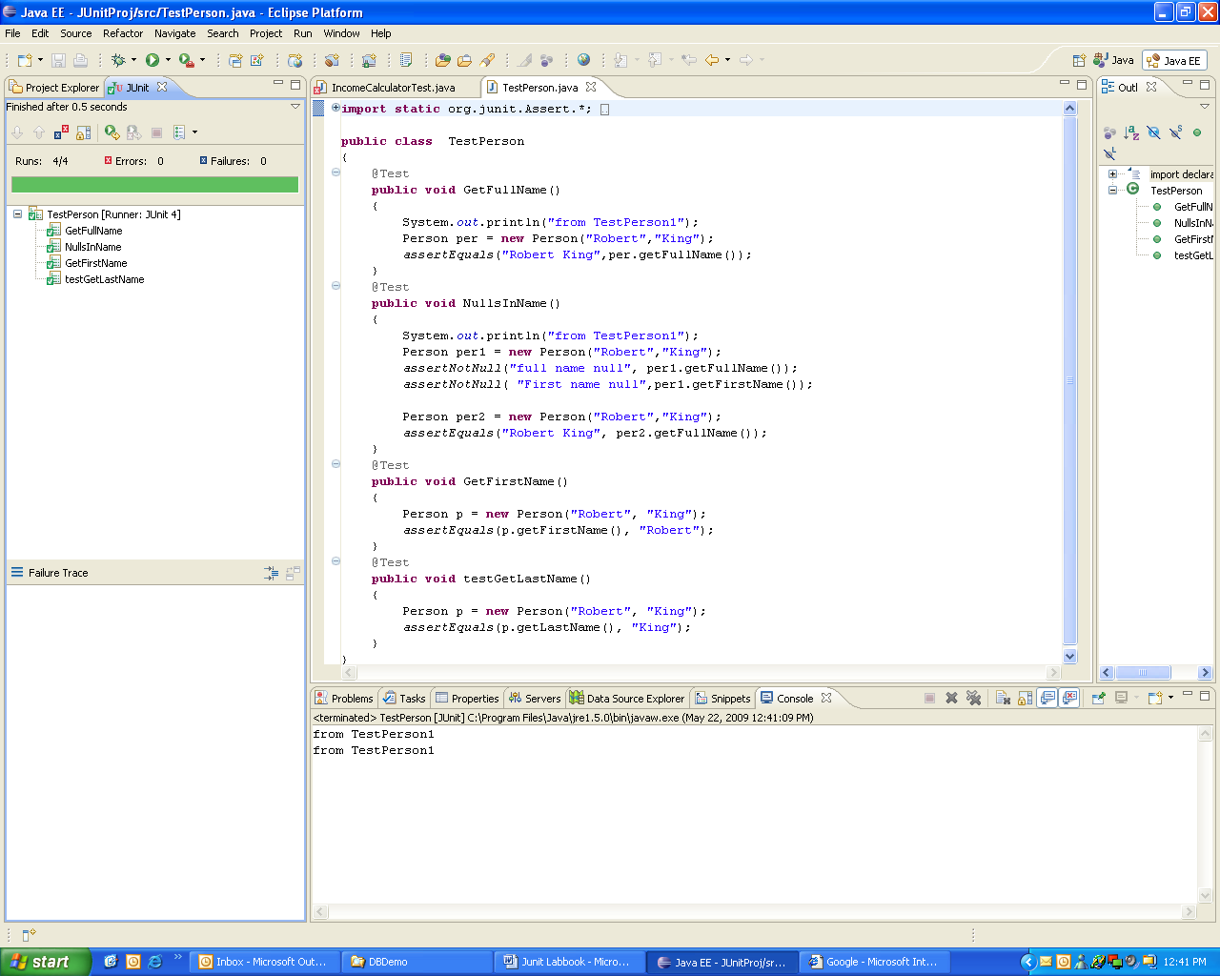

Figure 19: Output of JUnit text case execution

## 5.2: Writing JUnit tests

Consider the following Java program. Write tests for testing various methods in the class

Solution:

**Step 1:** Write the following Java Program **Date.java.**

class Date

{

intintDay, intMonth, intYear;

// Constructor

Date(int intDay, int intMonth, int intYear) {

this.intDay = intDay;

this.intMonth = intMonth;

this.intYear = intYear;

}

// setter and getter methods

voidsetDay(int intDay)

{

this.intDay = intDay;

}

intgetDay( )

{

return this.intDay;

}

voidsetMonth(int intMonth)

{

this.intMonth = intMonth;

}

intgetMonth( )

{

return this.intMonth;

}

voidsetYear(int intYear)

{

this.intYear=intYear;

}

intgetYear( )

{

return this.intYear;

}

public String toString() //converts date obj to string.

{

return “Date is “+intDay+”/”+intMonth+”/”+intYear;

}

} // Date class

Example 3: Date.java

**Step 2:** Write test class for testing all the methods of the above program and run it using the eclipse IDE.

**5.2.1:** Consider the Person class created in lab assignment 1.6. This class has some members and corresponding setter and getter methods. Write test case to check the functionality of getter methods and displaydetails method.

**5.2.2:** Consider the lab assignment **3.3** from Exception Handling Lab. Create a new class ExceptionCheck.java which handles an exception. Write a test case to verify if the exception is being handled correctly.

## Appendix A: Table of Figures

Figure 1: Java program 6

Figure 2: System Properties 7

Figure 3: Environment Variables 7

Figure 4: Edit System Variable 8

Figure 5: Edit System Variable 8

Figure 6: Edit User Variable 8

Figure 7: Select Wizard 9

Figure 8: New Java Project 9

Figure 9: Java Settings 10

Figure 10: Select Resource 10

Figure 11: Java Class 11

Figure 12: Sample output of Person details 14

Figure 13: Class Diagram of Person 14

Figure 14: Association of person with account class 16

Figure 15: Creating Java Project in Eclipse 20